

Explore Egypt / Team 12

Explore Egypt
User and Admin Guide
Version: <1.0>

Revision History

Sl. No. | Prepared/  Modified by | E-mail | Version | Date | Approved by | Descriptions/  Remarks
1. | Nooran Helmy | Nooran.helmi@hotmail.com | 1.0 | 12 May 2018

Table of Contents

1. Introduction 4
1.1. Purpose of this Document 4
1.2. Scope of Project 4
1.3. Release Information 4
1.4. Table of Acronyms and Definitions 4
1.5. References 4
1.6. Overview of Document 5
2. Target Platform 5
3. Installation Instructions 5
4. Getting started 5
5. Usage Instructions 6
1. Create an account. 6
2. Log in. 7
3. Forget Password. 8
4. Log Out. 9
5. View Museums 10
6. Add Sites 11
7. View Sites 12
8. Edit Sites 13
9. View/Add/Delete Tour Guides 13
10. View/Add/Delete Advertisers 14
11. Add Advertisement 14
12. Pay Fees 15
6. Troubleshooting 16
1. Password is incorrect 16
7. Points of Contact 16

List of Tables

List of Figures

Introduction
This document is the user and admin guide for the web application “Explore Egypt”.
The purpose of this document is to guide the user to use the software probably, describes the functionalities in the software and how to use them.

Purpose of this Document
The goal of this document is to help the user getting started with the software, know what the website offers.

  - Scope of Project
Explore Egypt is a web application that are intended to encourage tourism in Egypt. It facilitates to the tourist the sites s/he can visit in every governorate in Egypt, gives information about the sites and their history. It also targets domestic tourism as it reveals the hidden places in Egypt.

  - Release Information
<Give information on the release of the software for which this document is written: version # and release date>
Version 2, 12 May 2018.

  - Table of Acronyms and Definitions

Term | Definition
OS | Operating System
PC | Personal Computer

  - References

N/A

  - Overview of Document

This document specifies the target platform in order to use the software. Shows the installation instructions and getting the user ready to start using the website. Shows the functionalities that the website offers and step-by-step instructions on how to use each functionality. At Last, it shows the user how to solve some expected errors that might happen to the user.

Target Platform
Platform | Laptops
Platform | PCs
OS | Windows
OS | Linux
OS | Mac OS
Browser | Any browser

Installation Instructions
There are no installation instructions for the software as it is a web application, and no files are needed to be placed on the hard disk. Visit the website through your preferred browser.

Getting started
- Open your preferred browser.
- Type the link of the website in the address bar.
- You are in the homepage of the website, you can navigate the website without creating an account or you can choose to create an account.

Usage Instructions

Create an account.
To create an account, from the homepage click on “Create new account”.
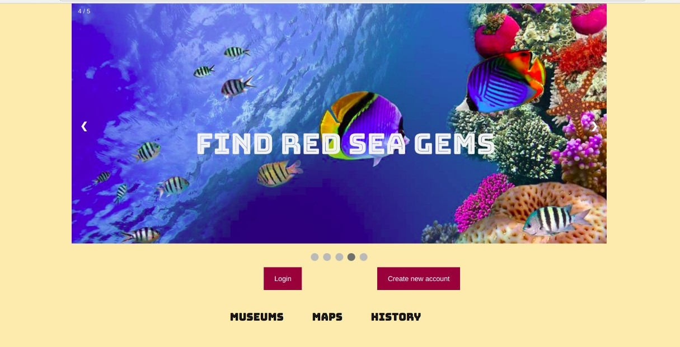

A window will appear, write a username, a password and an email. Choose the type of your account; tourist, tour guide or advertiser, then click on “Create account”.

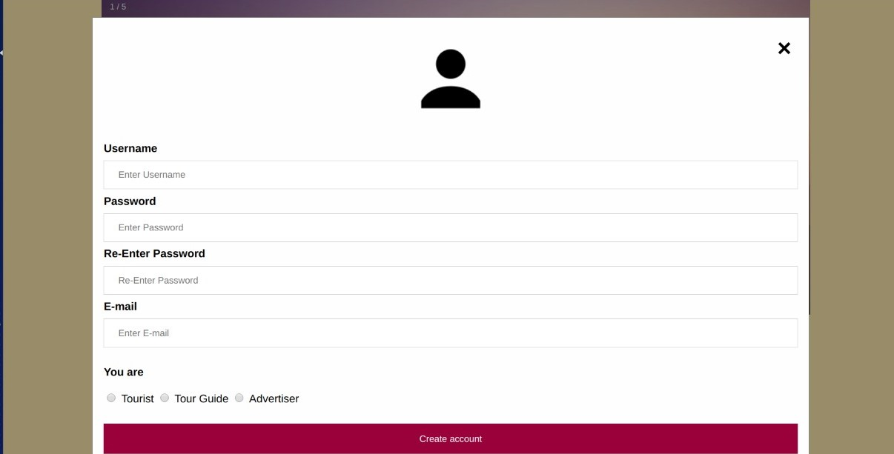
The username is any set of letters, numbers and special characters, you are free to choose your username unless it is not repeated before.

Now, you have created an account successfully!

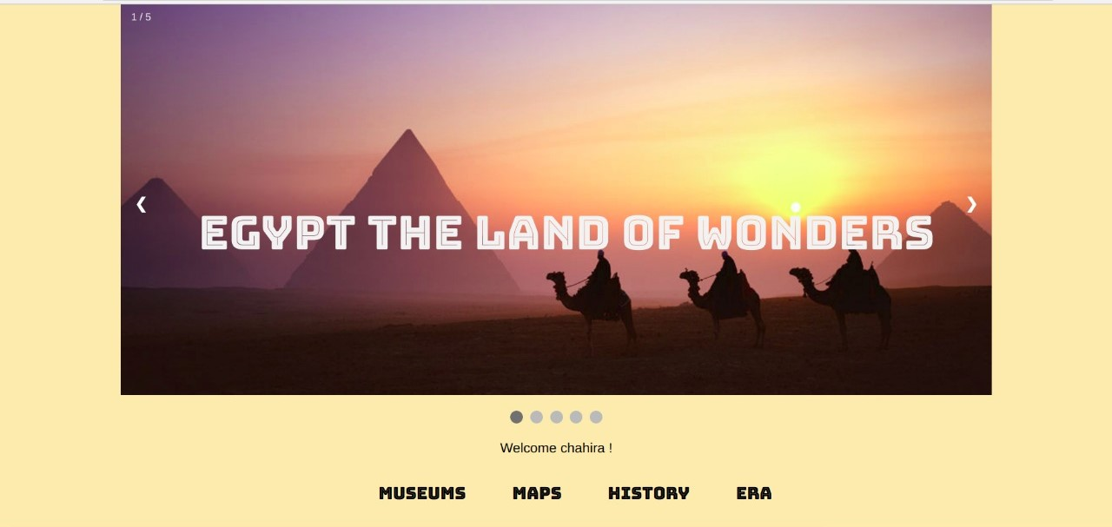

Log in.
To login into your account after creating it, from the homepage click on “Login”.
A window will appear, write your username and password and click “Login”.

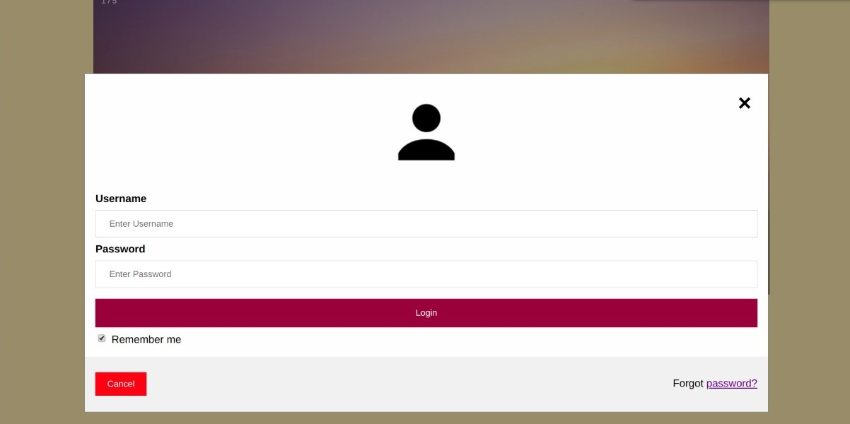
You can login into your account later without typing your username and password again, by checking the “Remember me” box.

Now, you have logged in successfully!

Forget Password.

If you forgot your password, you can reset it at any time. From the homepage click “Login”. A window will appear asking you to enter your username and password. From this window click on “Forgot password?”

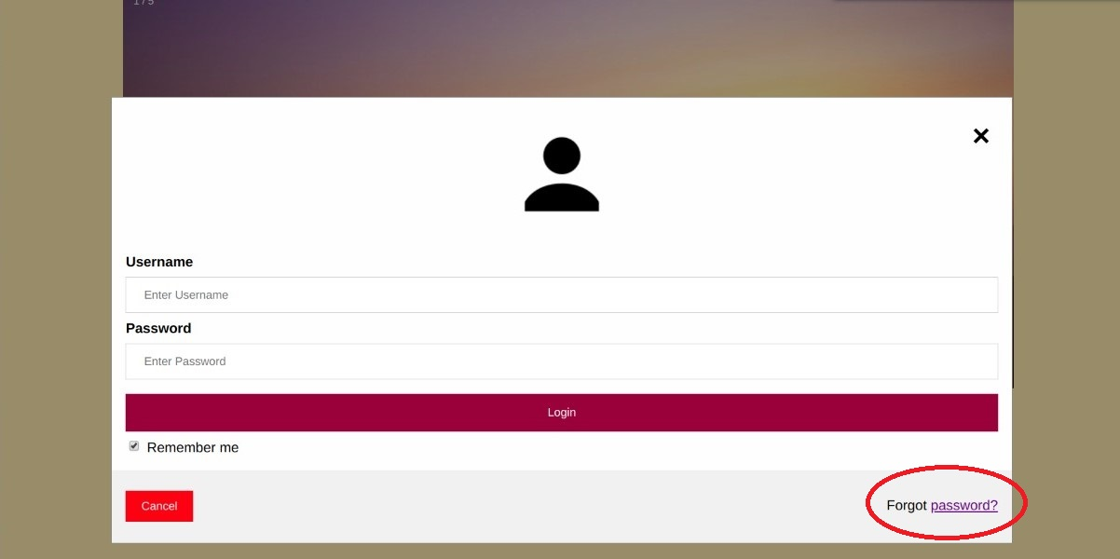

You will be asked to enter an email, in the text box enter the email you have used to create your account and click “Okay”.

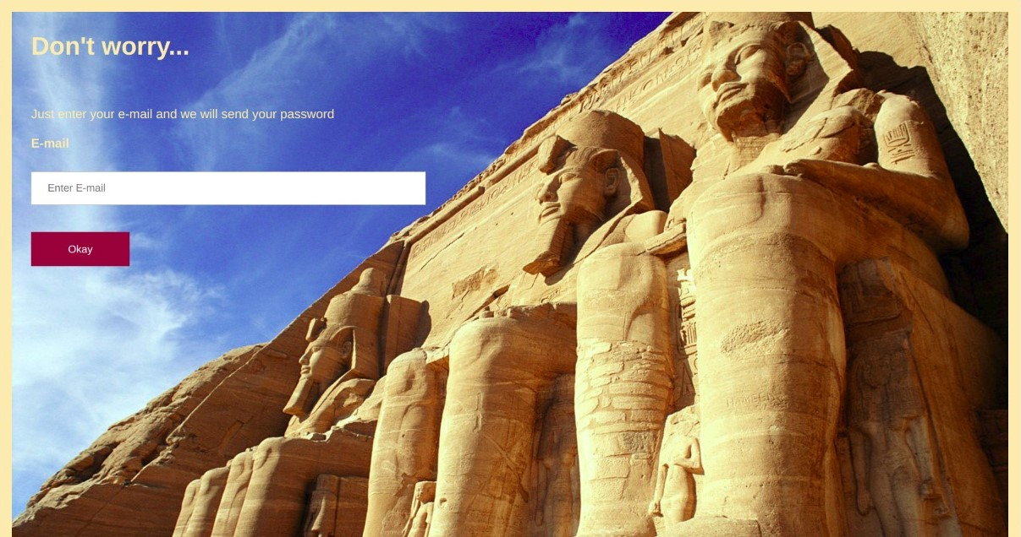

Log Out.
Log out from your account after you have logged in, you are returned to the homepage again.

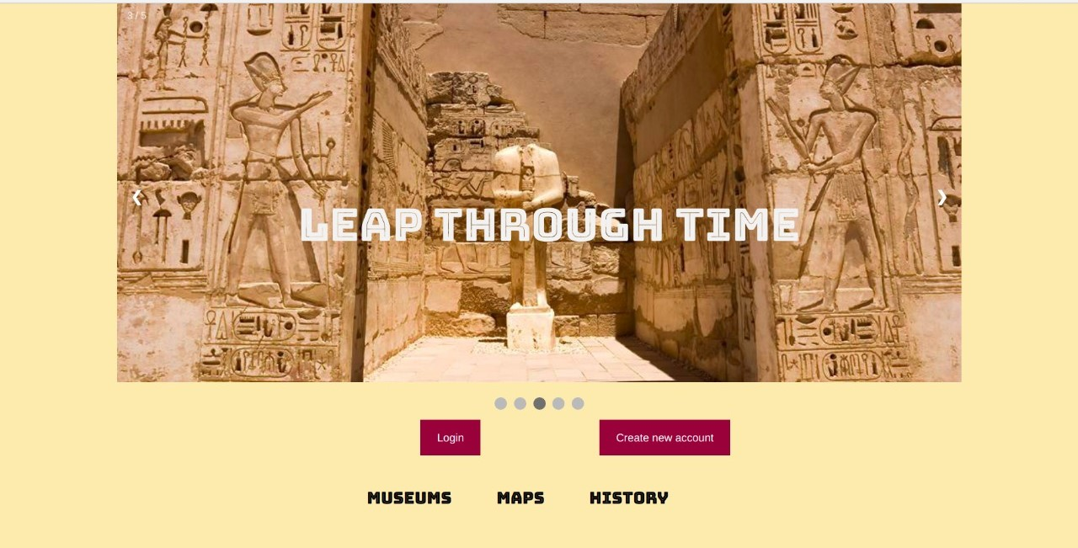

View Museums
You can view a museum as a guest or from your account. Click on “Museums” from the homepage to view the museums.

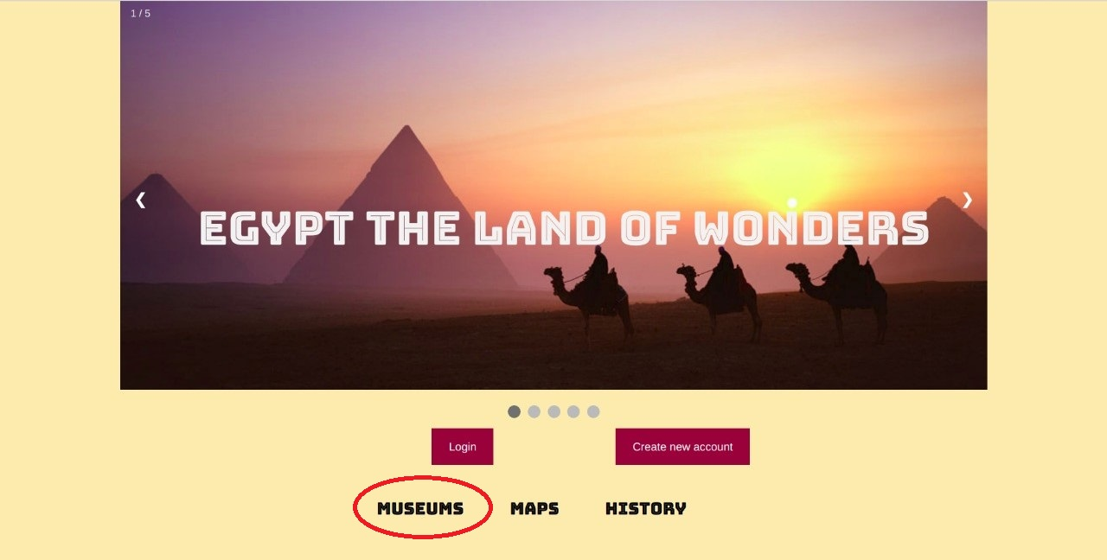

A page with the existing museums will appear, hover over each image to know the name of the museum.

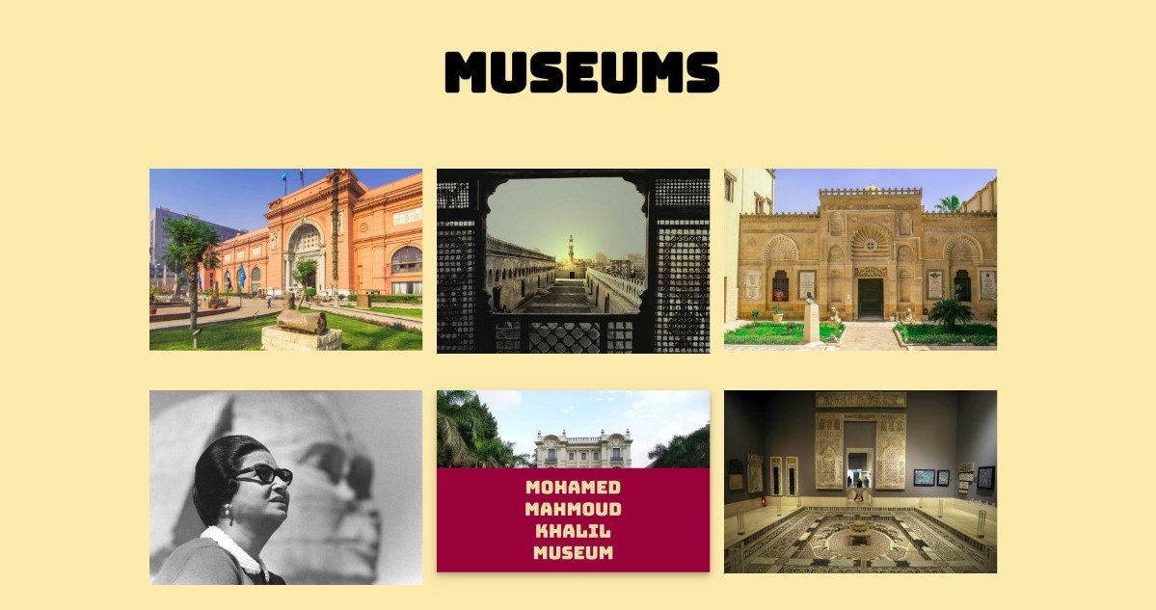

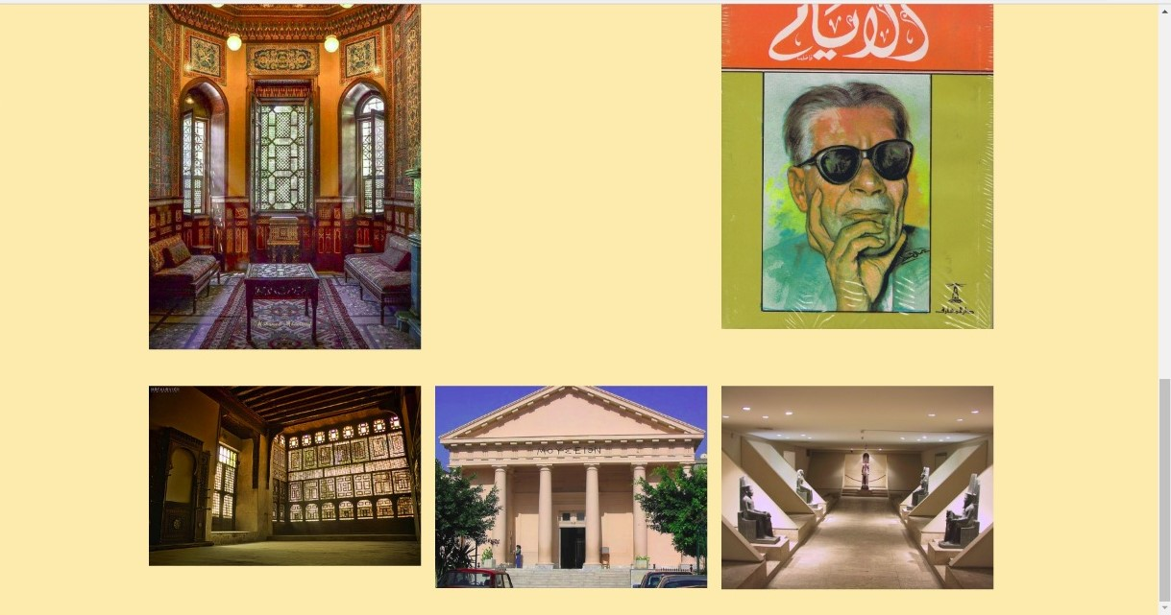

Add Sites
If you are an admin and you wish to add a new site to the website, from the admin homepage click “Add Sites”.

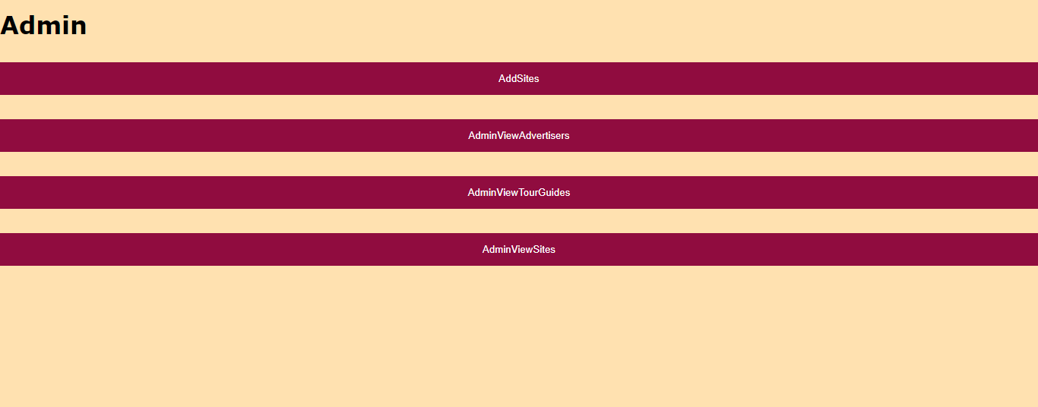

Choose the category of the site, add its name, address, description, the opening hours and a picture of the place then click “Add”.

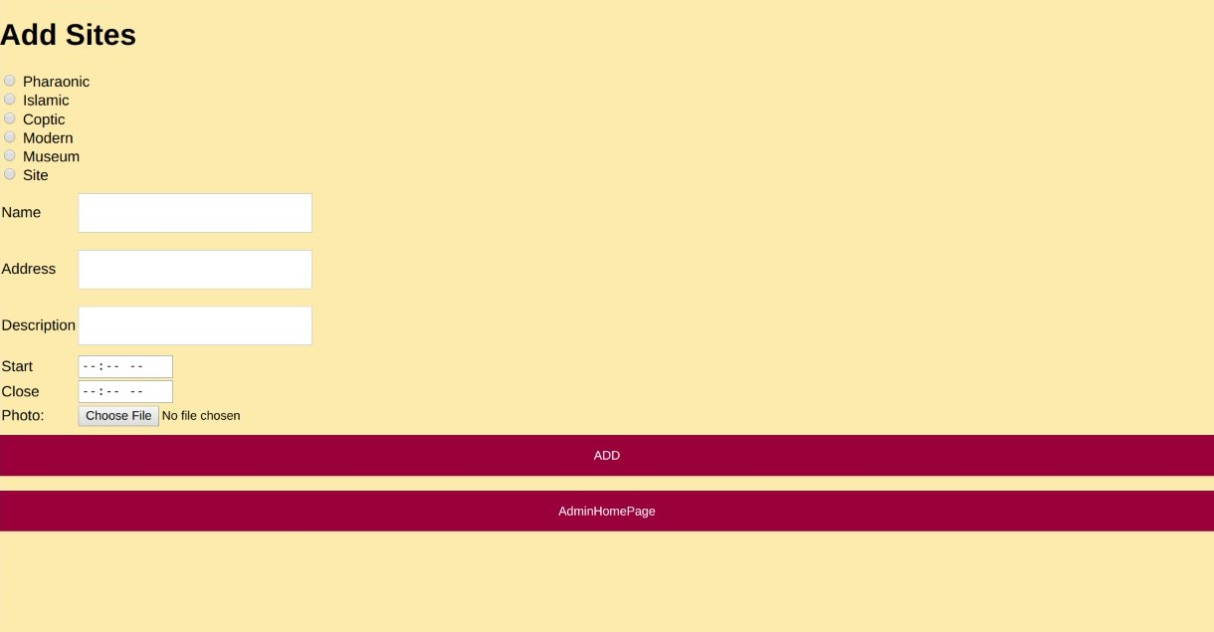

View Sites
To review all the sites you have added as an admin, from the admin homepage click “Admin View Sites”. Now you can view all the sites you have added before by clicking the next button.

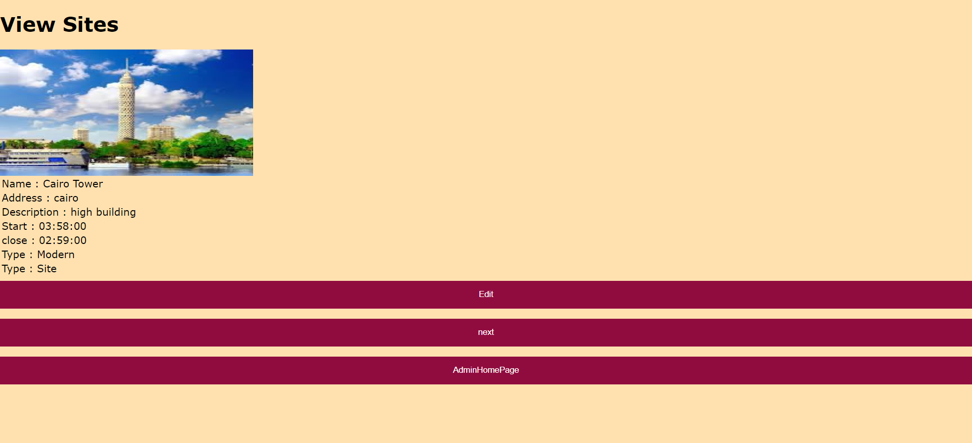

Edit Sites
If you are an admin and you wish to edit the information of a site already existing, you can do so by clicking “Admin View Sites” from the admin homepage as shown before. You can view all the existing sites, click next till you find the site you want to edit and click “Edit Site”.

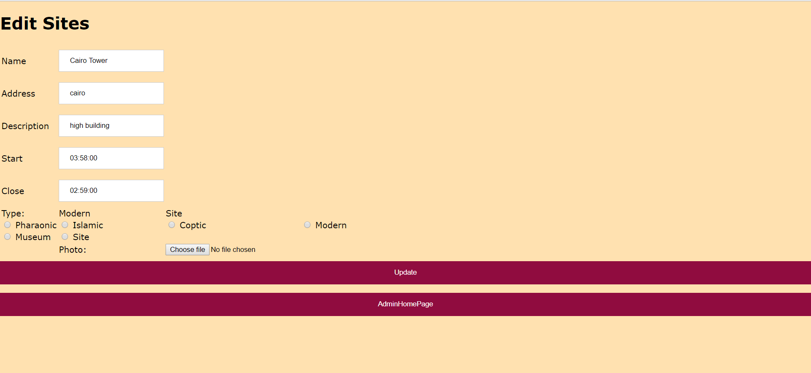

View/Add/Delete Tour Guides
If you are an admin and you want to view the tour guides already existing, click “View Tour Guides” from the admin homepage. Information about the tour guide will appear, you can either delete this tour guide if he is already existing, or add the tour guide if he requested to add himself as a tour guide or you can review the tour guides by clicking next.

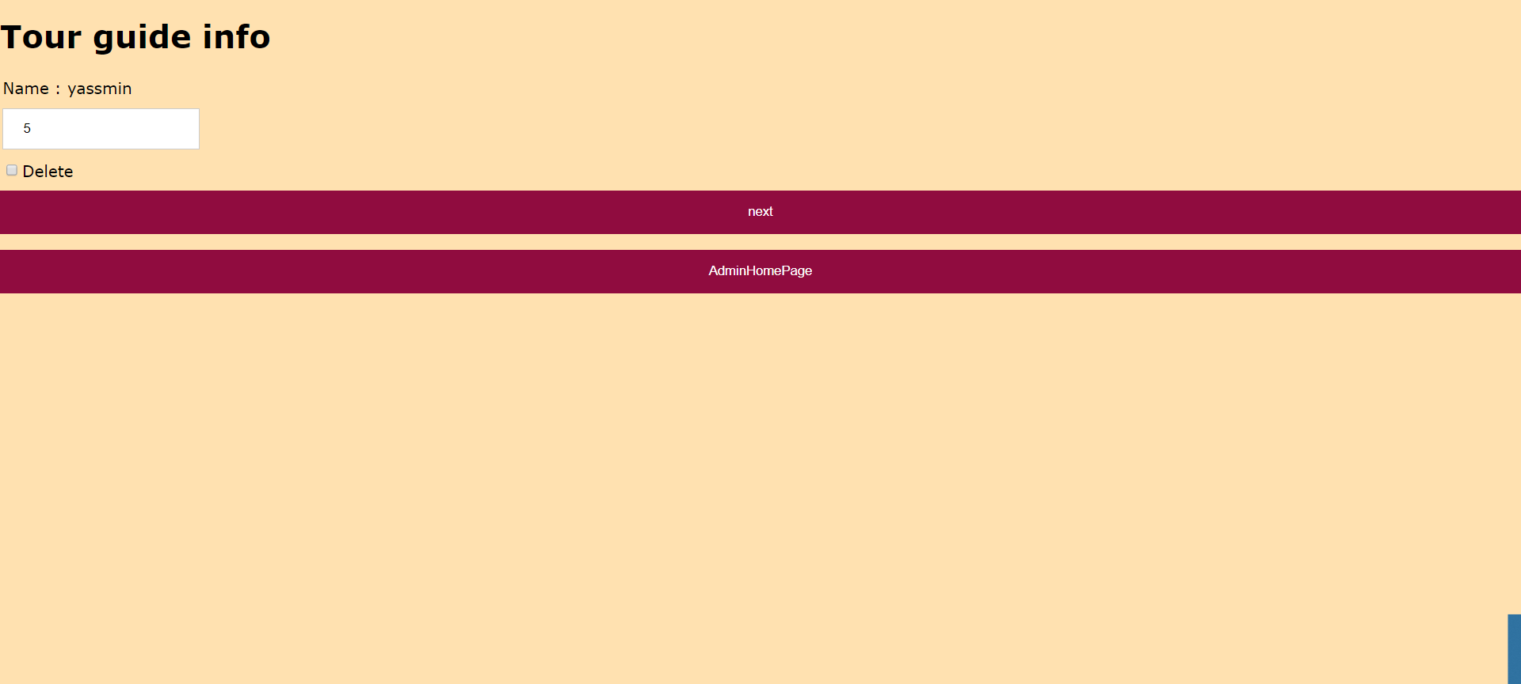

View/Add/Delete Advertisers
If you are an admin and you want to view the advertisers already existing, click “View Advertisers” from the admin homepage. Information about the advertisers will appear, you can either delete this advertiser if he is already existing, or add the advertiser if he requested to add himself as an advertisers or you can review the advertisers by clicking next.

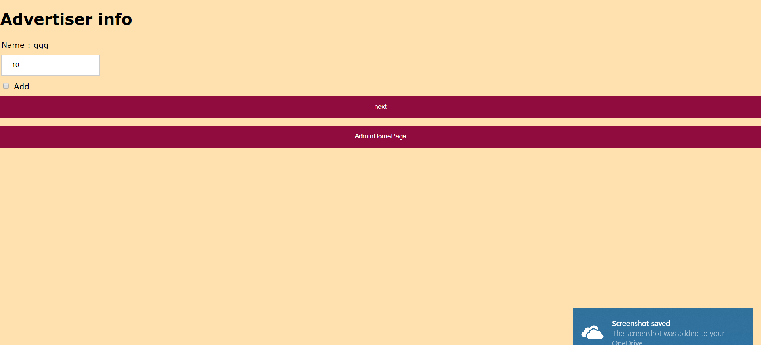

Add Advertisement
If you are an advertiser and wish to add a new advertisement, from the advertiser homepage click on “Add Advertisement”.

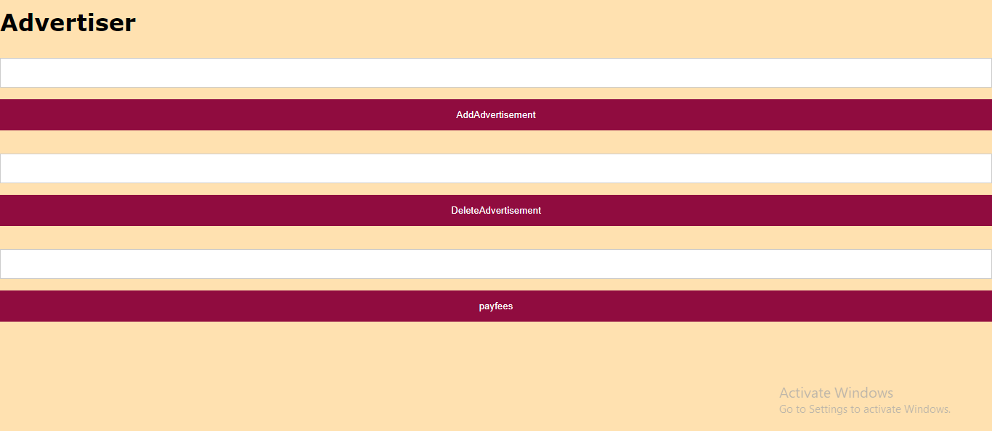
Add the information required, then click on “Add”.

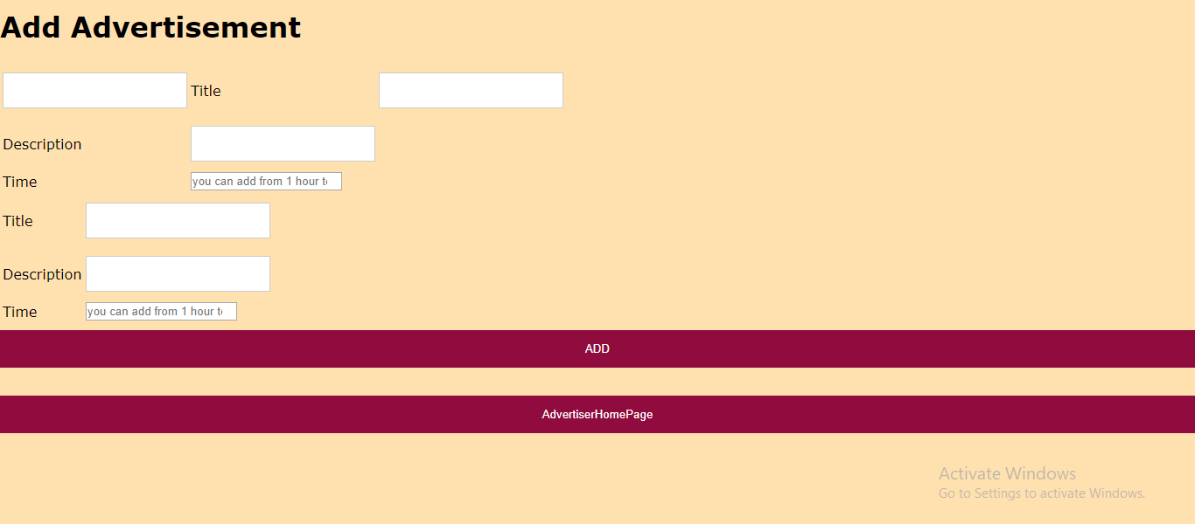

Pay Fees
As an advertiser, to pay the fees for your advertisements click on “Pay Fees” from the advertiser home page. Choose your paying method and enter the required information then click “Finish”.

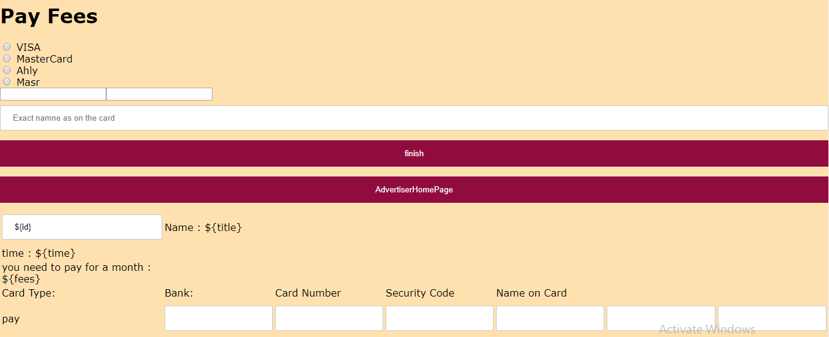

Troubleshooting
- Password is incorrect
If you are sure you remember your password but an error keeps telling you that the password is incorrect, make sure that the caps lock are off before you try to reset your password.

Points of Contact
You can contact us by sending an email to any of the following:

Chahia.hamza@live.com
Farah.amr.95@hotmail.com
Nooran.helmi@hotmail.com
shroukismailmohamed@gmail.com

